**Lab 8 – Create Dashboard from report**

Open the report and pin tiles to your dashboard

In the same workspace, select the PiReport report to open it.

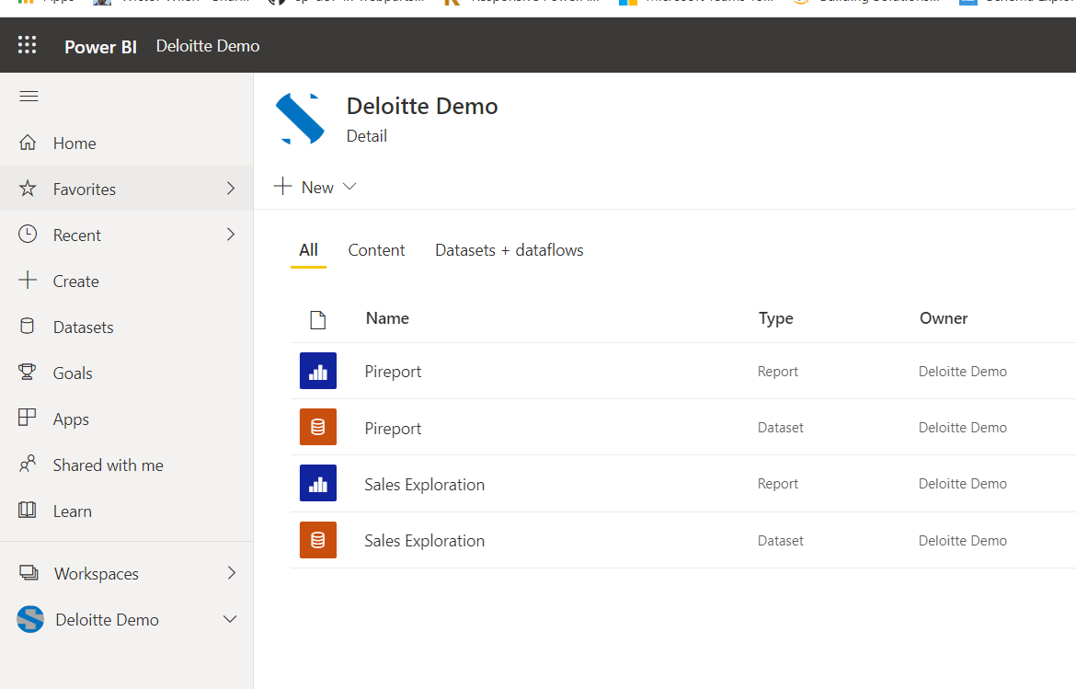

The report opens in Reading view.

Mouse over any one of the titles and click pin visual

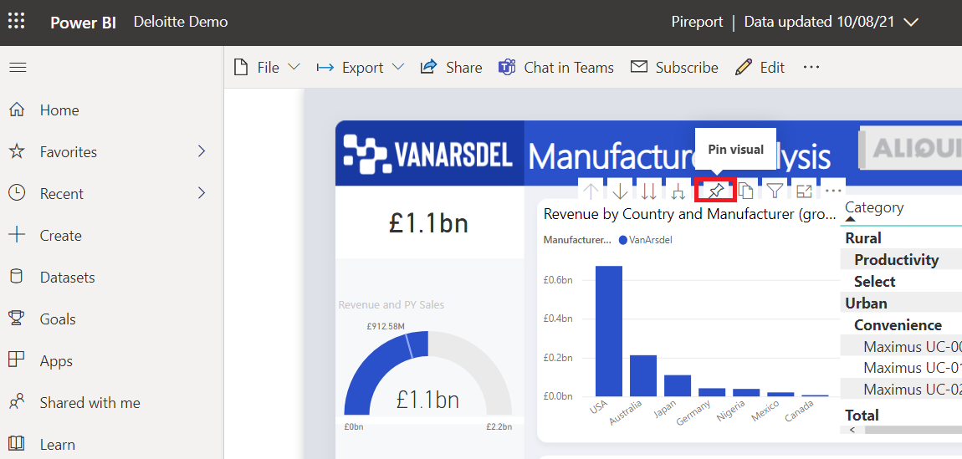

Because we're creating a new dashboard, select the option for ‘New dashboard’ and give it a name.

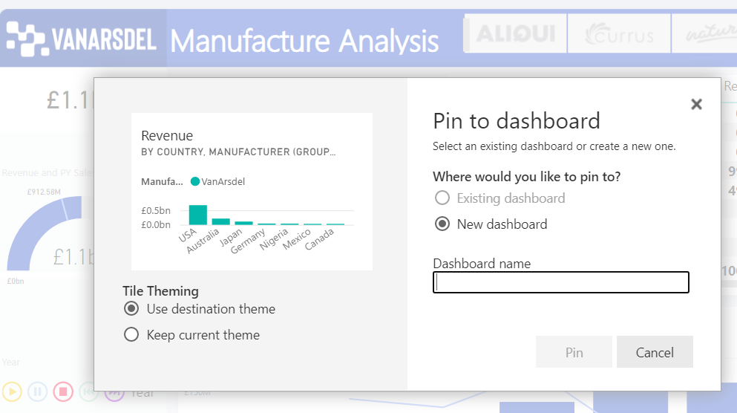

When you select **Pin**, Power BI creates the new dashboard in the current workspace. After the **Pinned to dashboard** message appears, select **Go to dashboard**. If you're prompted to save the report, choose **Save**.

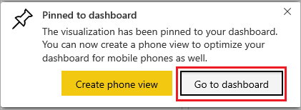

Power BI opens the new dashboard. It has one tile: the visualization you just pinned.

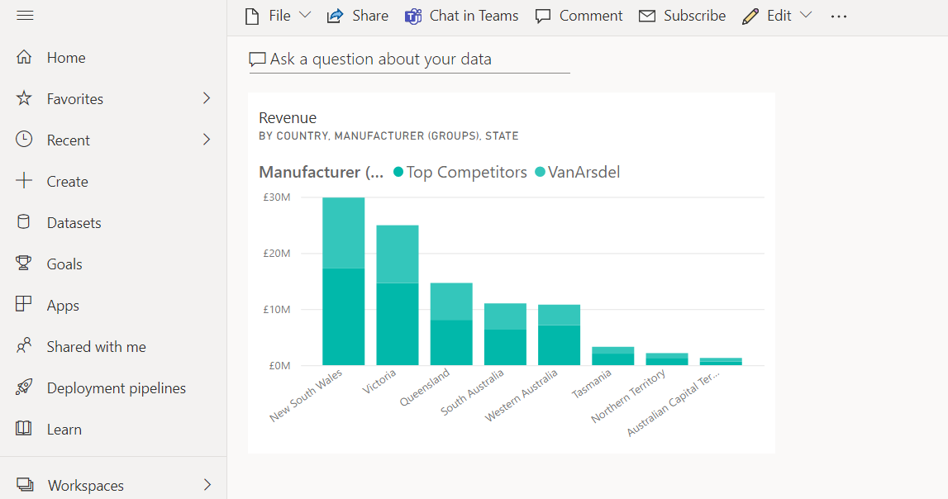

Select the tile to return to the report. Pin a few more tiles to the new dashboard. When the **Pin to dashboard** window displays, select **Existing dashboard**.

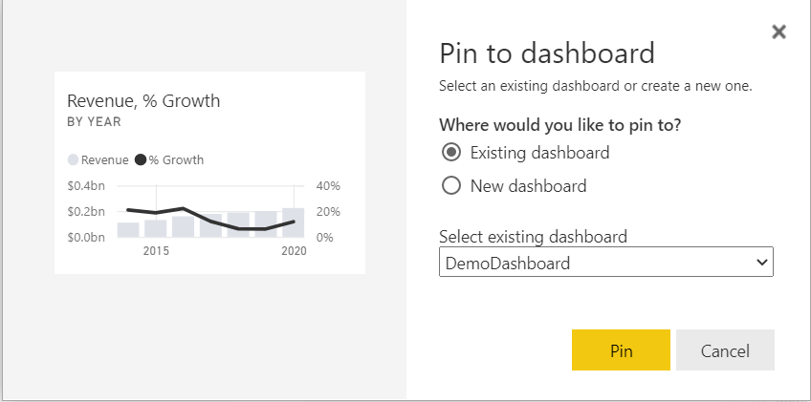

Then open next report and add the titles to your dashboard

**Pin an entire report page to the dashboard**

Instead of pinning one visual at a time, you can pin an entire report page as a live tile. Let's do it.

In the report editor, select the page you want to pin as dashboard

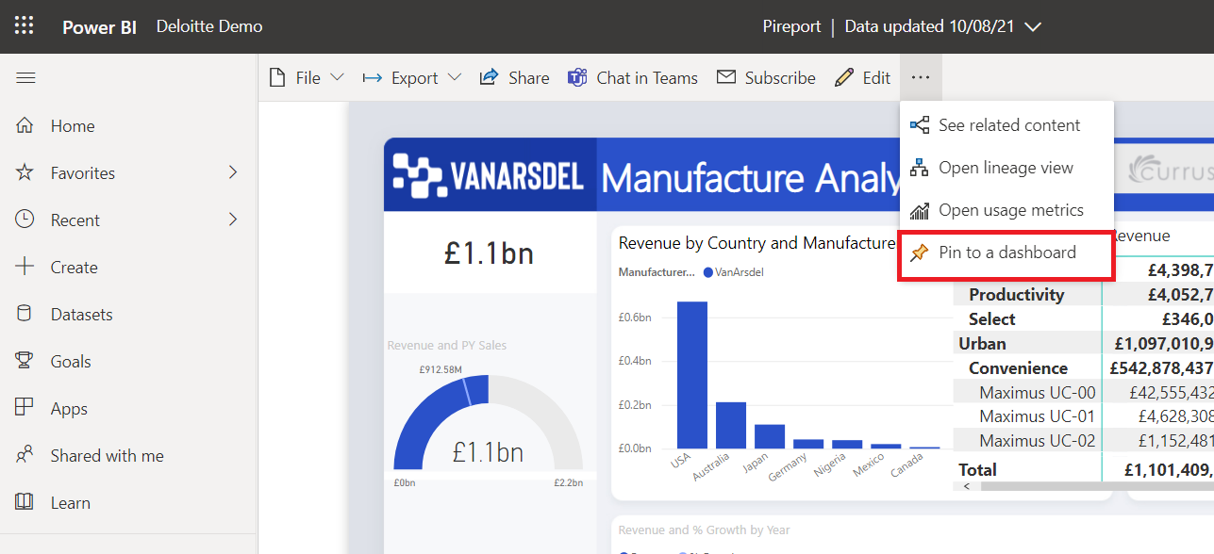

When the Pin to dashboard window appears, select Existing dashboard.

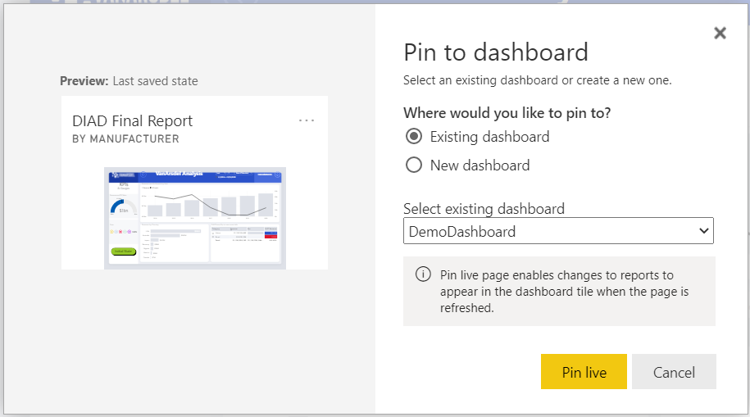

Pin live to pin the report as dashboard.

**Dashboard**

Then rearrange the dashboard and align all titles

* Change the theme
* Add header
* Q & A
* Set Alert

**Example output**

